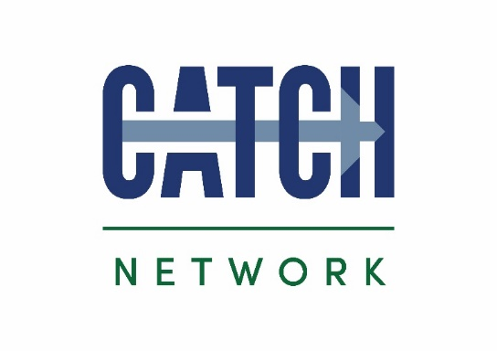
Sponsorship
Booking Form
Please supply a high-res version of your logo for use on event programme & website.
You may include hand-outs in delegate packs (75 copies by Monday 16th July 2087 please)

We will supply a table and power supply for your display stand.
You can set up on Weds 18 July 3-5pm or Thursday 19 July 7.30-8.30am

Please return completed booking forms to:
katie.hedges@catchuk.org
CATCH, Redwood Park Estate, Stallingborough, NE Lincolnshire, DN41 8TH

Contact details
Company name
Job title
Contact email address
Contact telephone number

Invoicing details
Purchase order number
Name
Position
Telephone number
Email address
Invoicing address
(including postcode)

Confirm Sponsorship package requested
Major Hazards Conference 20 July 2018 | £349
All prices exclude VAT

HCF CATCH is a Limited Company registered in England & Wales No. 3837010. Registered Office address: CATCH facility, Redwood Park Estate, Kiln Lane, Stallingborough, North East Lincolnshire, DN41 8TH
Tel: 01469 552 828 www.catchuk.org

