Programme
8.45 Arrival, Registration and Coffee
9.15 Welcome and Introduction
David Hughes, CATCH
9.20 Key Note Address
Craig Foyle, President IOSH

9.50 Health & Safety Executive & Chemicals, Explosives and Microbiological Hazards Division update
Peter Galsworthy & David Coackley, HSE

10.30 Coffee Break
11.00 An industry perspective on regulation and raising performance in the chemicals sector’
Phil Scott, Chemical Industries Association

11.35 Process Safety Topic case study
Graeme Ellis, ABB

12.10 Questions & Discussion
David Hughes, CATCH
12.15 Lunch & Networking
To book your place please email katie.hedges@catchuk.org or call 01469 552840

CATCH would like to thank all our sponsors for supporting this event:

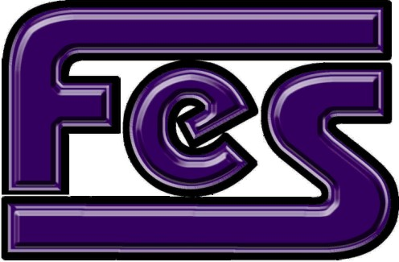

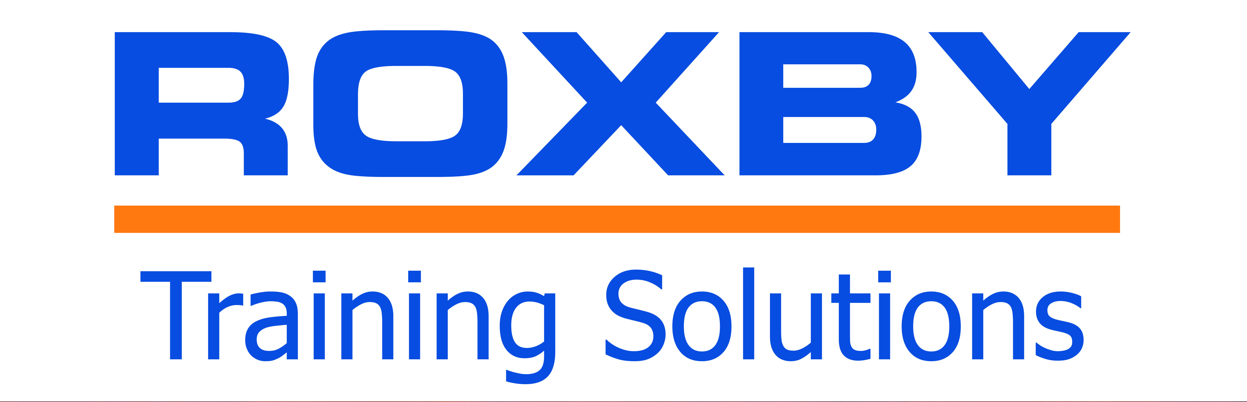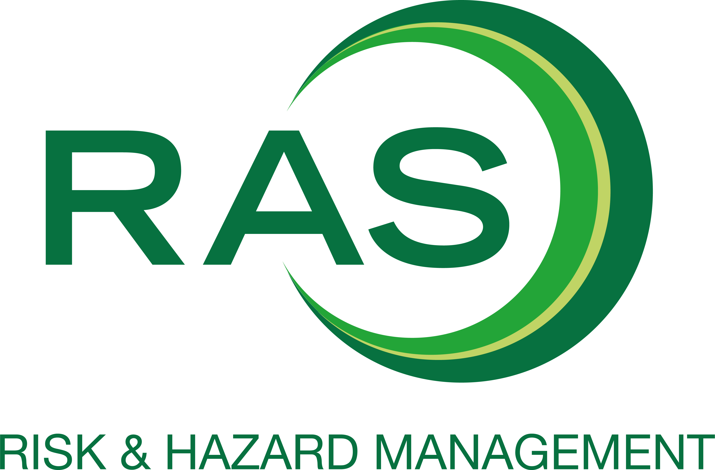

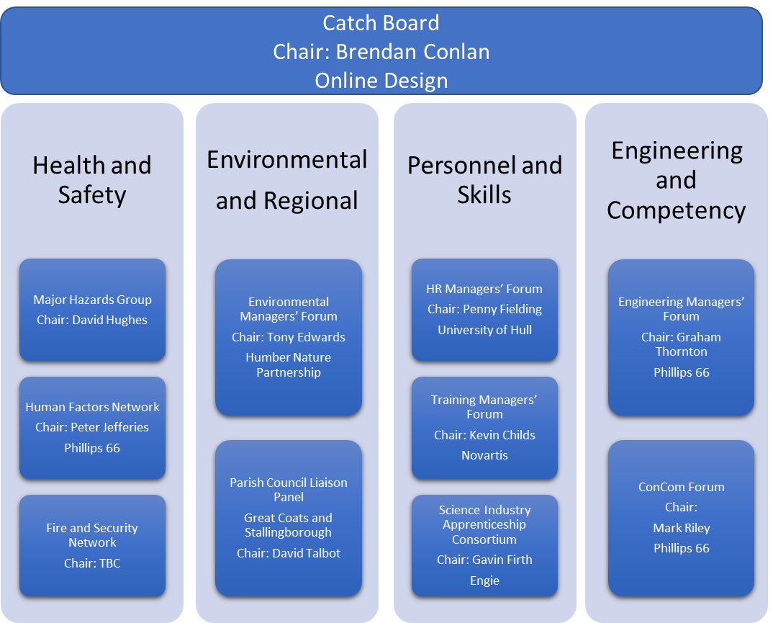

Please contact katie.hedges@catchuk.org for more details.
CATCH Major Hazards Group presents
Process Safety in the Humber
Learn from the HSE and practical experience from other speakers

Thursday 19 July 2018
CATCH Facility
Stallingborough
NE Lincolnshire
DN41 8TH

