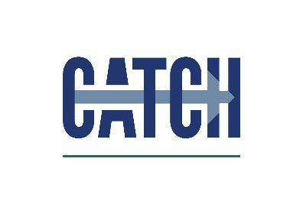
Sponsorship Booking Form

Please supply your logo for use on event programme & website
You may include hand-outs in delegate packs (50 copies by 4th June please)
Please let us know if you require a table and/or power supply for your display stand

Please return completed booking forms to Katie.hedges@catchuk.org

HCF CATCH Ltd, CATCH facility, Redwood Park Estate, Kiln Lane, Stallingborough, North East Lincs, DN41 8TH

Contact details
Company name
Job title
Contact email address
Contact telephone number

Invoicing details
Purchase order number
Name
Position
Telephone number
Email address
Fax number
Invoicing address
(including postcode)

Confirm Sponsorship package requested
Environmental Conference 6 June 2018 | £200
All prices exclude VAT

HCF CATCH is a Limited Company registered in England & Wales No. 3837010. Registered Office address: CATCH facility, Redwood Park Estate, Kiln Lane, Stallingborough, North East Lincolnshire, DN41 8TH
Tel: 01469 552 828 www.catchuk.org

