Lessons from Incidents
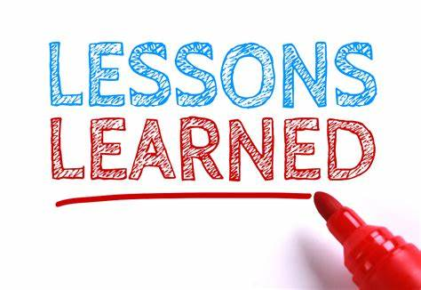
Do we truly learn the lessons from incidents?
Most organisations face the challenge in trying to ensure the lessons from the past are learnt and embedded into their operations. The issue is bigger in the 21st Century than ever before – a site does not just need to learn from their own events, but companies are also expected to share learning across their facilities where appropriate. In the high hazard industries, companies are also required to review and adopt learnings from elsewhere outside their company which may be relevant to their operations. This gives a potentially massive source of information.
If we add into the mix that the aspect of workforce mobility, the concept of Corporate Knowledge sitting within the people in an organisation is more challenging. The emphasis shifts to the systems, procedures and training in place to ensure new-starts are aware of the WHAT, HOW and WHY of the job as well as any relevant history behind why things are the way they are!
How can we assure ourselves the original actions from an incident are still in place?
Let’s start with the investigation itself. Most companies use internal trained incident investigators for all but the most serious incidents. These individuals use various techniques to identify what went wrong, the immediate causes and root causes. Actions are identified and allocated to prevent recurrence. Some companies build in a “Peer Review” at this point to allow challenge of the investigation findings by employees / experts not directly involved. This can provide a more thorough test of the investigation findings. Once agreed, the actions are then implemented as required. Upon completion, many of the Action Management Systems available require someone to verify the action is complete. The rigour of this process varies in my experience – some organisations use the number of open actions as a metric which can encourage the premature closure of actions as complete when the job has been put onto a worklist but is not actually complete. A better practice is to only sign an action off when the final intent of the action has been put in place! Once the actions have been verified as complete this is the end of the process.
A good practice I would encourage for serious incidents is to build in a review / audit of these actions in the future – say 3-5 years after the actions are completed. This allows a degree of assurance that the actions are still in place. Having this review / audit completed by one of the original investigation team can provide further assurance that the original intent has been met – sometimes the action implemented may not actually match the intent of the recommendation made.
But how can we improve the knowledge and understanding of the workforce regarding the incident and steps taken? In the short term following the incident it is likely that communication would be put in place, procedures may be updated and training carried out. This addresses the immediate issue for the workforce at that time, but … many companies face issues with an ageing workforce who may be approaching retirement, or a highly mobile workforce who move companies regularly, so how can these aspects be addressed? During my career I found myself as the longest-serving operational member of a management team after less than 4 years’ service. Hence it is possible a modern manager may not know why something was put in place and may inadvertently make decisions to remove control measures put in place following an incident in the past.
Some cultures around the world use storytelling to pass their history from generation to generation. In the modern world there is a mass of information on the internet, multiple short videos and animations prepared, and many companies use e-learning systems for training. I believe e-learning has its place, particularly in pre-screening for prior knowledge before a training session, but on its own I worry it is potentially over-utilised.
A practice I came across during the early days of my career with ICI was a regular event where one of the experienced Process Safety specialists would lead a workshop focusing on various incidents from the local plants, or from a worldwide perspective. These sessions were facilitated group discussions with a few photographs on slides, drawings (before the days of Powerpoint), setting the question “what went wrong” and “how could it have been prevented”. The group discussions that followed were very informative, where participants in the workshop (engineers of all levels of experience) would share their thoughts and experiences. These sessions were extremely effective, they were always oversubscribed, and were a vehicle to ensure the lessons from the past are embedded into an organisation.
How robust are your systems for ensuring the lessons from the past are not forgotten?

