2020

Membership

Survey Results

www.catchuk.org

**Communication**

Nearly three quarters of our members read our monthly e-newsletter and event update emails.

And just over a quarter did not know these updates existed. We are always updating our communications list, please get in touch if you would like to be included.

We have over 2000 members and subscribers on our distribution list, from across the process manufacturing, chemical, renewable and engineering industries including the associated supply chain.

PAGE 1

2020

**MEMBERSHIP**

**SURVEY RESULTS**

Thank you to all our members and associates who took the time to complete our 2020 membership survey.

We are delighted with the results! The figures show that our Members find our benefits and services useful and value for money. The results also gave us confidence to start and offer new services within our membership across the Yorkshire and Humber region. We have taken on board feedback and will ensure our newsletters and communications are more visible and easier to subscribe to.

We have improved our website pages, so that our membership benefits are more accessible and easier to understand.

The report below outlines the results in further detail.

If you have any questions about our membership services, please contact Katie or Lisa.

**Services**

CATCH operates across various departments; we asked our members which CATCH services they have used in order for us to find out where and how we can sign post our members better.

The results we good, many of members have taken advantage of the first class services we offer here at CATCH.

**Events**

Following on from our networks, we also operate our event programme. Over 60% of those responded have attended one or more of our open events.

We have gathered topics and suggestions for future events and will use these going forward when planning the 2021 event programme.

Feedback from members tells us that our events are found useful, informative and members leave with takeaways to implement in their own businesses.

77% are happy with out half day networks and events, plus 33% of people advised that they would like us to run webinars.

**Networks**

All CATCH networks are very well attended, and the vast majority led by an industry chair.

Our most popular networks are Human Factors, Major Hazards and our Environmental Managers network. These networks feed our event programme to ensure they are relevant for our Members.

We have introduced two new networks to Yorkshire – HR Managers and Engineering Managers – with more to follow if required.

Our new decarbonisation network is underway, which is great as this co-insides with a specific request from our membership.

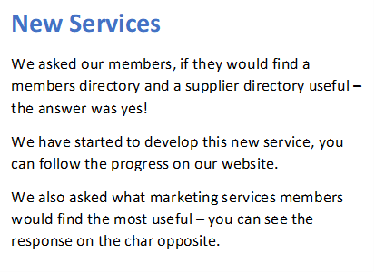

**Find out more**

[www.catchuk.org](http://www.catchuk.org)

Linkedin / Twitter / Facebook

Contact –

[Katie.hedges@catchuk.org](mailto:Katie.hedges@catchuk.org)

[Lisa.buck@catchuk.org](mailto:Lisa.buck@catchuk.org)

Subscribe to our newsletters and regular updates

**What do you like about your catch membership?**

Quality of training, brilliant "safe" industrial training facilities, people are easy to get on with, knowledgeable, value for money, flexibility to deliver what we need, when we need it.

Engagement in the chemicals sector and support from catch and other members

Local Hub

Accessibility

networking & events – access to likeminded organisations

**New Services**

We asked our members, if they would find a members directory and a supplier directory useful – the answer was yes!

We have started to develop this new service, you can follow the progress on our website.

We also asked what marketing services members would find the most useful – you can see the response on the chart opposite.